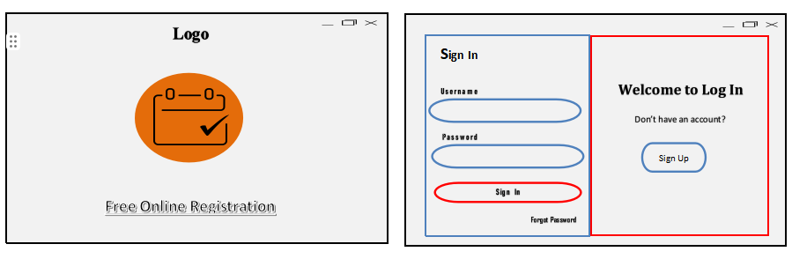**System Prototype**

**Welcome Page**: Displays the logo and a "Free Online Registration" button to start.

**Sign-In Page**: Users log in or click "Sign Up" to create an account.

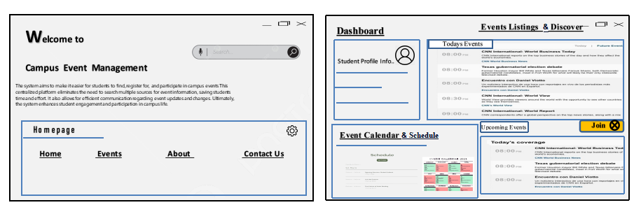

**Dashboard**: Features Event Listings to view/join events and an Event Calendar to track them.

**Home Page**: Explains the system's purpose with a menu (Home, Events, Contact Us) for easy navigation.